Title in the original language of the manuscript
Translated title (either Spanish or English if the manuscript is written in Spanish)
Name Surname¹, Name Surname^{2,*}, Name Surname^{1,3}
¹ Institution/Centre and address of authors. ORCID: https://orcid.org/xxxx-xxxx-xxxx-xxx1, https://orcid.org/xxxx-xxxx-xxxx-xxx3
² Institution/Centre and address of authors. ORCID: https://orcid.org/xxxx-xxxx-xxxx-xxx2
³ Institution/Centre and address of authors. ORCID: https://orcid.org/xxxx-xxxx-xxxx-xxx3
*Corresponding author: email@adress.com
ABSTRACT
Here goes the abstract in the original language of your manuscript.
Preferably under 500 words, clearly indicating objectives, approach and main conclusions.
Keywords: keyword1; keyword2; keyword3.
RESUMEN
Translated abstract to English if the manuscript is in Spanish or French, or to Spanish if the manuscript is written in English.
Palabras clave: Palabra1; Palabra2; Palabra3.
First section
Add a maximum of three levels of sections (main section, subsection, sub-subsection). Do not use numbers. Use the font styles provided in this template. In general, the following structure of main sections is recommended:
- Introduction
- Geological setting
- Materials and Methods
- Results
- Discussion
- Conclusions
Subsection 1
First order subsections are to be indicated in italics adjusted to left. Do not use numbers.
Sub-subsection1
Second order subsections are to be in included in non-italics smaller size.
Sub-subsection2
Lorem ipsum dolor sit amet, consectetuer adipiscing elit. Maecenas porttitor congue massa. Fusce posuere, magna sed pulvinar ultricies, purus lectus malesuada libero, sit amet commodo magna eros quis urna. Nunc viverra imperdiet enim. Fusce est.
Subsection 2
Lorem ipsum dolor sit amet, consectetuer adipiscing elit. Maecenas porttitor congue massa. Fusce posuere, magna sed pulvinar ultricies, purus lectus malesuada libero, sit amet commodo magna eros quis urna. Nunc viverra imperdiet enim. Fusce est. Vivamus a tellus. Pellentesque habitant morbi tristique senectus et netus et malesuada fames ac turpis egestas. Proin pharetra nonummy pede.
Section 2
Lorem ipsum dolor sit amet, consectetuer adipiscing elit. Maecenas porttitor congue massa. Fusce posuere, magna sed pulvinar ultricies, purus lectus malesuada libero, sit amet commodo magna eros quis urna. Nunc viverra imperdiet enim. Fusce est. Vivamus a tellus. Pellentesque habitant morbi tristique senectus et netus et malesuada fames ac turpis egestas.
SUPPLEMENTARY FILES
If applicable, include here a brief description of each supplementary file.
DATA AVAILABILITY
If applicable, include here a brief description of the data type deposited in repositories, name or identification code of the files, license of use and distribution and URL.
ACKNOWLEDGEMENTS
Do not include funding data here
DECLARATION OF COMPETING INTEREST
This section must be completed in all articles with the following text (choose your language):
The authors of this article declare that they have no financial, professional or personal conflicts of interest that could have inappropriately influenced this work.
Los/as autores/as de este artículo declaran no tener conflictos de intereses financieros, profesionales o personales que pudieran haber influido de manera inapropiada en este trabajo.
Les auteurs de cet article déclarent qu'ils n'ont aucun conflit d'intérêt financier, professionnel ou personnel qui aurait pu influencer ce travail de manière inappropriée.
FUNDING
Indicate the code and title of the project/grant/contract etc that supported your work, the name of the funding entity (and optional acronym).
AUTHORSHIP
This section must be incorporated in all articles, including all authors with the following format example, including all roles that apply in each case (use CRediT taxonomy):
First author's name and surname: Include here all roles that apply separated by comma (Conceptualization, Data curation, Formal Analysis, Funding acquisition, Investigation, Methodology, Project administration, Resources, Software, Supervision, Validation, Visualization, Writing – original draft, Writing – review & editing).
Second author’s name and surname: idem (check https://credit.niso.org/contributor-roles-defined/ for info on each role)
References
Reference 1 in APA referencing style
Reference 2 in APA referencing style

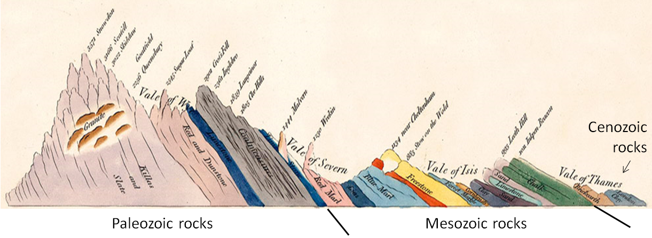
Figure 1.— Caption to the figure 1.
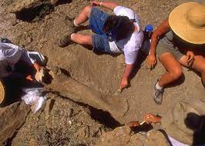
Figure 2.— Caption to the figure 2.
Table 1.— Title of the table.

